**Project Design Phase-I**

**Solution Architecture**

|  |  |
| --- | --- |
| Date | 19 September 2023 |
| Team ID | NM2023TMID08200 |
| Project Name | iRevolution: A Data-driven Exploration of Apple's iPhone Impact in India |
| Maximum Marks | 4 Marks |

**Solution Architecture:**

The Tableau solution architecture encompasses a holistic framework designed to meet specific business needs through effective data visualization and analytics. Beginning with a clear understanding of business requirements, the architecture identifies data sources and integrates them into Tableau, employing data modeling and preparation techniques for optimal visualization. Deployment considerations include infrastructure choices, while security measures ensure data integrity and controlled access**.**

**Example - Solution Architecture Diagram:**

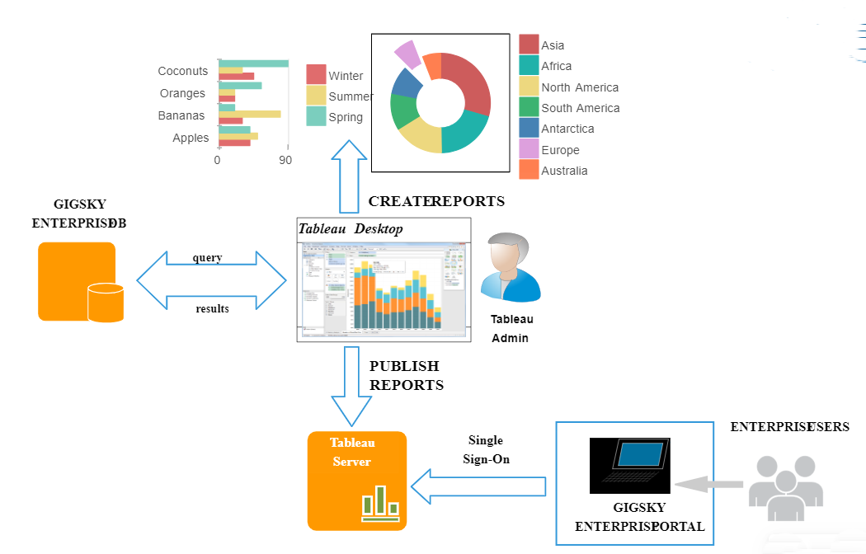

**Reference:**

https://creately.com/diagram/example/i7d38o861/tableau-architecture-classic